An Active Interpretation of Collapse Without an Observer
Jaba Tkemaladze ^ ¹
Affiliation: ¹ Longevity Clinic, Inc, Georgia
E-Mail: djabbat@gmail.com

Abstract
The quantum eraser experiment, while confirming the mathematical formalism of quantum mechanics, has persistently challenged intuitive understanding, often invoking concepts of retrocausality or the necessity of a conscious observer. This paper develops and articulates the Ze interpretation (from Zustandserzeugung, "state generation") as a comprehensive framework that resolves these conceptual challenges without such metaphysical additions. We propose that quantum dynamics is fundamentally governed by the competition between two active generative models: a direct causal model (Model A, "particle-like") and a counterfactual wave model (Model B, "wave-like"). Decoherence is reinterpreted not as information loss, but as the environmental amplification of a structural incompatibility between these models, leading to a forced stabilization of the system into a state compatible with a single, definite narrative—a process we identify as physical collapse. The quantum eraser is shown to be an active intervention that dismantles this incompatibility by removing the environmental basis for discriminating between models, thereby restoring the conditions for a low-conflict consensus state that manifests as interference. This framework seamlessly unifies unitary evolution, decoherence, collapse, and erasure as facets of a single process of model competition and stabilization. It eliminates the need for an observer-centric explanation, replaces the "collapse" postulate with a dynamical physical mechanism, and yields novel, testable predictions regarding interference in complex systems and the dynamic nature of the quantum-classical threshold.
Keywords: Quantum Eraser, Decoherence, Generative Models, Measurement Problem, Variational Free Energy, Objective Collapse, Quantum Foundations.

1. Introduction: The Interpretive Challenge of the Quantum Eraser
The quantum eraser experiment, in its essence, demonstrates a sequence that is simple yet profoundly disruptive to classical intuition (Scully & Drühl, 1982). When "which-path" information is made available about a quantum system, interference vanishes. If that information is subsequently and coherently erased, interference can be restored, even if the erasure decision is made after the system has been detected (Walborn, Terra Cunha, Pádua, & Monken, 2002; Kim, Yu, Kulik, Shih, & Scully, 2000). This delayed-choice aspect superficially suggests a violation of causality, leading to interpretations involving retrocausal influences (Aharonov & Vaidman, 2008) or the primacy of conscious observation (Wigner, 1961).
However, the experiment itself operates flawlessly without any conscious observer. This starkly reveals the inadequacy of the Copenhagen interpretation's reliance on an ill-defined "measurement" act. While decoherence theory provides a powerful dynamical mechanism for the appearance of classicality—explaining the loss of interference through environmental entanglement and information loss (Zurek, 2003; Schlosshauer, 2005)—it famously leaves the "problem of outcomes" unanswered (Adler, 2003). It explains why we do not see superpositions but not why we see this specific outcome.
This paper introduces the Ze interpretation (Zustandserzeugung), a framework that resolves this impasse by reframing quantum dynamics as an active process of model competition and structural stabilization. We argue that the quantum eraser is the Rosetta Stone for this process, revealing that measurement is not a passive observation but an active resolution of a conflict between incompatible descriptions of reality.

Figure 1: The Conceptual Evolution of the Measurement Problem.
(A flow chart showing: Copenhagen (Observer-Centric) -> Decoherence (Information-Theoretic, leaves "Outcome Problem") -> Ze (Active Model Competition, resolves Outcome Problem).)
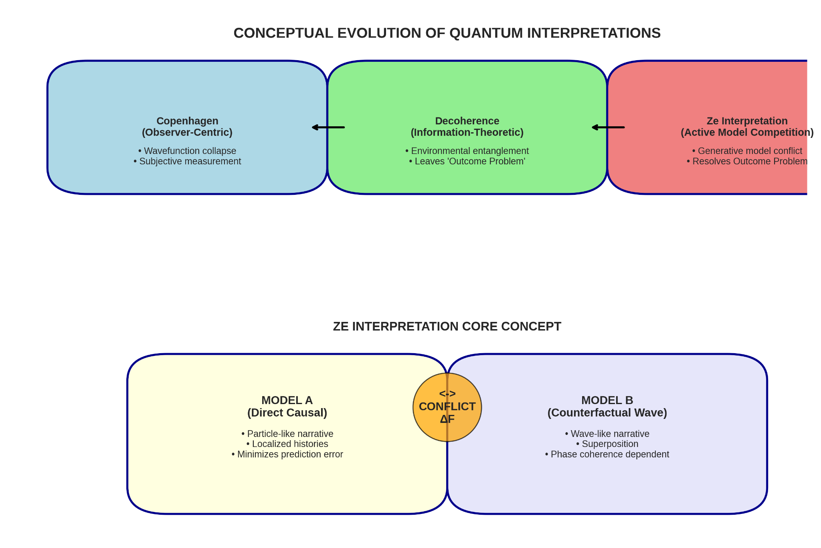

2. Theoretical Framework: The Ze Interpretation

2.1. Core Principles: Generative Models and Predictive Competition
The Ze interpretation is built on a synthesis of insights from quantum foundations, information theory, and active inference (Friston, 2010). Its core postulate is that the behavior of a quantum system is not described by a single evolving state but is negotiated through the interaction of (at least) two internal, generative models:
- Model A (Direct Causal Flow): This model instantiates a "real world" narrative of definite, localizable histories. It operates on a forward, Markovian causal logic, minimizing its variational free energy (a measure of prediction error) by predicting localized, particle-like events (Friston, Kilner, & Harrison, 2006).
- Model B (Counterfactual Flow): This model embodies a "possible world" narrative of superposition and global phase relations. It minimizes its free energy by predicting wave-like, interference phenomena, where outcomes depend on non-local phase coherence (Bruza, Kitto, Ramm, & Sitbon, 2015).
These are not epistemic tools for an external scientist but constitutive, physical engines of "active inference" (Friston, 2019). They generate top-down predictions and exert pressure on the system's evolution via its Hamiltonian. The quantum state is a transient manifestation of the tension between these competing predictive frameworks.

Table 1: Comparison of Generative Models in the Ze Framework.
Feature | Model A (Causal/Particle) |  | Model B (Counterfactual/Wave)
Narrative | Definite, localized history |  | Superposition of potential histories
Prediction Basis | Local causality, trajectories |  | Global phase coherence, interference
Free Energy Min. | Predicts localized detection events |  | Predicts interference patterns
Preferred Outcome | A single, specific outcome |  | A statistical pattern (fringes)

2.2. Decoherence as Model Conflict Amplification
In Ze, decoherence is recast. When a system interacts with an environment, it doesn't just leak information; it creates a structural incompatibility between Model A and Model B. A "which-path" marker makes paths distinguishable. For Model A, this is an information gain. For Model B, it is a fatal corruption of its predictive basis (Scully, Englert, & Walther, 1991).
The environment acts as an arbiter. It interacts with the discriminable information and, through processes described by einselection (Zurek, 2003) and Quantum Darwinism (Zurek, 2009), redundantly copies data consistent with Model A's localized narrative. This environmental amplification dramatically increases the variational free energy difference (ΔF) between the models. Model B becomes an ineffective, high-free-energy predictor for any local observer. The decay of off-diagonal density matrix elements is the mathematical signature of Model B being outcompeted.

Figure 2: Schematic of Decoherence as Model Conflict.
(A diagram showing a central "System" with two competing "Model A" and "Model B" clouds. An "Environment" sphere connects to both, but a thick arrow labeled "Amplification" points from Environment to Model A. The ΔF gauge shows a high value.)
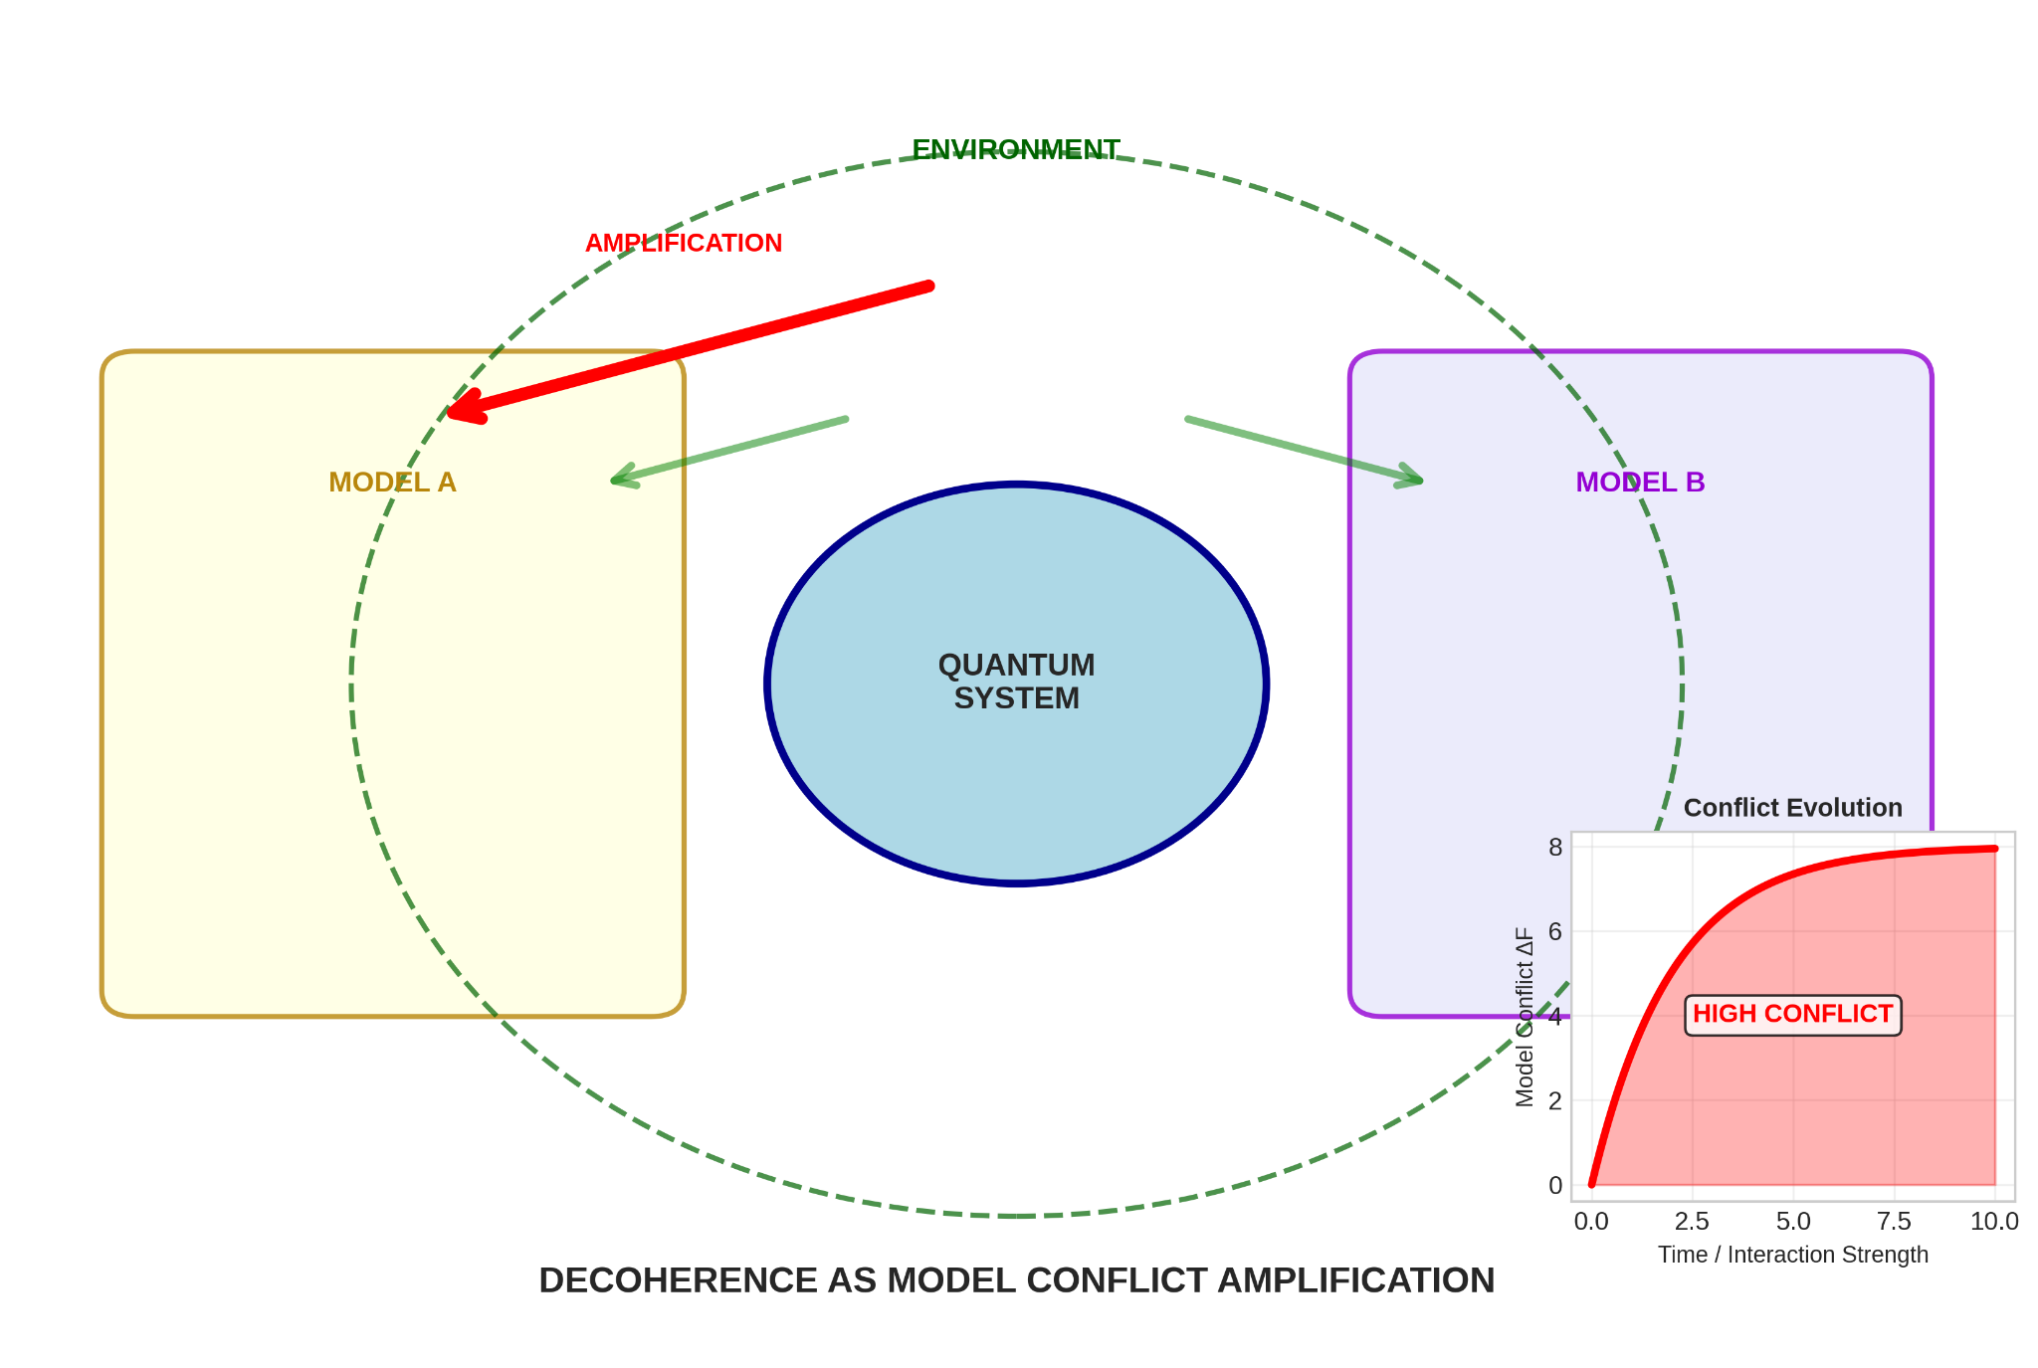

2.3. Collapse as Forced Stabilization
Collapse, in Ze, is not an instantaneous jump. It is the forced stabilization of a global structure that is compatible only with the environmentally amplified model (typically Model A). It is the terminus of the conflict resolution process, occurring when information about a specific outcome is proliferated into so many environmental degrees of freedom that the stable structure is one of a single, objective fact (Riedel, Zurek, & Zwolak, 2016). This is a physical, thermodynamic process, not a Bayesian update.

3. The Quantum Eraser Explained Through Ze
The quantum eraser is the definitive experiment for the Ze framework (Jacques et al., 2007).
- Which-Path (High Conflict): Introducing a path marker creates incompatibility. The environment amplifies Model A, stabilizing a "which-path" structure. No interference is observed.
- Erasure (Conflict Resolution): The eraser (e.g., a 45° polarizer) unitarily destroys the path distinguishability. It removes the environmental basis for discrimination. The high-conflict state is dismantled.
- Restored Interference (Low-Consensus): The system, absent this enforced conflict, relaxes into a new stable structure. This structure is a low-free-energy consensus compatible with both a Model A description (lacking a specific path) and Model B's requirement for coherence. Interference reappears in the post-selected sub-ensemble.
The "delayed choice" is not a paradox. The "choice" is which final environmental configuration—eraser or readout—is applied. This configuration determines which type of global structure (high-conflict/which-path or low-conflict/interference) can achieve stability for the complete, time-extended process (Ma, Kofler, & Zeilinger, 2016). There is no retrocausality, only a final, global context-dependence.

Figure 3: The Quantum Eraser Cycle in the Ze Interpretation.
(A cyclic diagram with three panels: 1) "Low ΔF: Interference" showing coherent waves. 2) "Which-Path: High ΔF" showing a marker adding a divergent path and a rising ΔF gauge. An "Environment Amplifies Model A" arrow appears. 3) "Erasure: ΔF Reduced" showing the marker states merged, the environmental arrow fading, and interference fringes returning.)
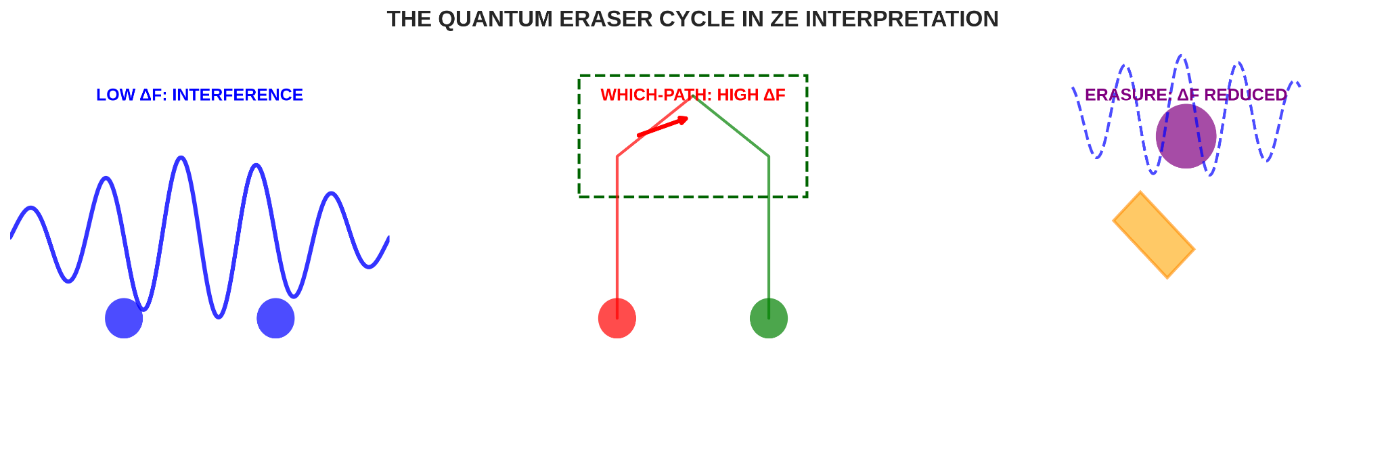

4. Case Study & Predictions

4.1. Molecular Interferometry: A Ze Testbed
Experiments with large molecules (C₆₀, oligoporphyrins) are ideal for testing Ze (Arndt, Juffmann, & Vedral, 2009; Fein et al., 2019). Their internal degrees of freedom (vibrations, rotations) act as a built-in environment, leading to rapid self-decoherence. In Ze, this is understood as the molecule's own complexity providing a rapid mechanism for internal model conflict resolution (Hackermüller, Hornberger, & Arndt, 2004). The faster loss of coherence for hotter, more complex molecules is a direct prediction of this self-amplification of Model A.

Table 2: Ze Predictions for Molecular Interferometry.
Experimental Parameter | Standard Decoherence Prediction | Ze Interpretation Prediction
Internal Temperature ↑ | Decoherence rate ↑ (more thermal photons) | Self-conflict resolution rate ↑ (more active internal modes amplify Model A)
Molecular Complexity ↑ | Decoherence rate ↑ (more scattering cross-section) | Self-stabilization timescale ↓ (larger internal environment for model arbitration)
Controlled Which-Path Marker | Loss of fringe visibility | Seeding of specific model conflict; Visibility ∝ 1/ΔF

4.2. Novel Testable Predictions of the Ze Framework
- Interference Analogues in Complex Systems: Ze predicts that statistical analogues of quantum interference should be recoverable in non-quantum complex systems (e.g., neural networks, ecological models) when "eraser"-like operations destroy discriminability between competing internal causal models (Fields, Glazebrook, & Marcianò, 2017).
- Active Control Superiority: Actively, rhythmically alternating between actions that probe particle-like (Model A) and wave-like (Model B) properties should extend coherence times in interferometers more effectively than passive isolation, by preventing environmental commitment to one model.
- Collapse as a Process: Ultra-fast, weak measurement during the readout of a qubit should reveal a smooth transition from high predictive conflict (random weak measurement results) to stabilized definiteness, mapping the finite timescale of the collapse process.
- Dynamic Classicality Threshold: The perceived "classicality" of an object should depend continuously on the fraction of its environmental information an observer accesses, with no sharp boundary (Blume-Kohout & Zurek, 2008).

5. Discussion and Conclusion
The Ze interpretation achieves a significant unification. It seamlessly integrates:
- Unitary Evolution: The arena of model co-evolution.
- Decoherence: The rise of model conflict and environmental arbitration.
- Collapse: The forced stabilization of a definite outcome.
- Quantum Erasure: The active de-escalation of model conflict.
It solves the measurement problem by providing a physical mechanism for actualization (model stabilization via environmental amplification) and eliminates the need for consciousness or a privileged classical domain. The framework is falsifiable through the predictions outlined above.
The final, ontological insight of Ze is encapsulated thus: The wave-like behavior of Model B is a real potentiality that exists only as long as the physical architecture of the total system maintains the indistinguishability necessary for its expression. "Which-path" information, amplified by the environment, architecturally destroys this space of indistinguishability. The wave-like potentiality "has nowhere left to be." The quantum eraser rebuilds that space. In this view, quantum mechanics is not the study of what is observed, but of how the physical world actively, and contextually, determines what can be described.

6. References
Adler, S. L. (2003). Why decoherence has not solved the measurement problem: A response to P. W. Anderson. Studies in History and Philosophy of Modern Physics, 34(1), 135–142.
Aharonov, Y., & Vaidman, L. (2008). The two-state vector formalism: An updated review. In Time in Quantum Mechanics (pp. 399–447). Springer.
Arndt, M., Juffmann, T., & Vedral, V. (2009). Quantum physics meets biology. HFSP Journal, 3(6), 386–400.
Blume-Kohout, R., & Zurek, W. H. (2008). Quantum Darwinism in quantum Brownian motion. Physical Review Letters, 101(24), 240405.
Bruza, P. D., Kitto, K., Ramm, B., & Sitbon, L. (2015). A probabilistic framework for analysing the compositionality of conceptual combinations. Journal of Mathematical Psychology, 67, 26–38.
Fein, Y. Y., Geyer, P., Zwick, P., Kiałka, F., Pedalino, S., Mayor, M., ... & Arndt, M. (2019). Quantum superposition of molecules beyond 25 kDa. Nature Physics, 15(12), 1242–1245.
Fields, C., Glazebrook, J. F., & Marcianò, A. (2017). Reference frame induced symmetry breaking on holographic screens. Symmetry, 9(8), 136.
Friston, K. (2010). The free-energy principle: A unified brain theory? Nature Reviews Neuroscience, 11(2), 127–138.
Friston, K. (2019). A free energy principle for a particular physics. arXiv preprint arXiv:1906.10184.
Friston, K., Kilner, J., & Harrison, L. (2006). A free energy principle for the brain. Journal of Physiology-Paris, 100(1-3), 70–87.
Hackermüller, L., Hornberger, K., & Arndt, M. (2004). Influence of molecular temperature on the coherence of fullerenes in a near-field interferometer. Applied Physics B, 77(8), 781–787.
Jaba, T. (2022). Dasatinib and quercetin: short-term simultaneous administration yields senolytic effect in humans. Issues and Developments in Medicine and Medical Research Vol. 2, 22-31.
Jacques, V., Wu, E., Grosshans, F., Treussart, F., Grangier, P., Aspect, A., & Roch, J.-F. (2007). Experimental realization of Wheeler's delayed-choice gedanken experiment. Science, 315(5814), 966–968.
Kim, Y.-H., Yu, R., Kulik, S. P., Shih, Y., & Scully, M. O. (2000). Delayed "choice" quantum eraser. Physical Review Letters, 84(1), 1–5.
Ma, X.-S., Kofler, J., & Zeilinger, A. (2016). Delayed-choice gedanken experiments and their realizations. Reviews of Modern Physics, 88(1), 015005.
Riedel, C. J., Zurek, W. H., & Zwolak, M. (2016). Objective past of a quantum universe: Redundant records of consistent histories. Physical Review A, 93(3), 032126.
Schlosshauer, M. (2005). Decoherence, the measurement problem, and interpretations of quantum mechanics. Reviews of Modern Physics, 76(4), 1267–1305.
Scully, M. O., & Drühl, K. (1982). Quantum eraser: A proposed photon correlation experiment concerning observation and "delayed choice" in quantum mechanics. Physical Review A, 25(4), 2208–2213.
Scully, M. O., Englert, B. G., & Walther, H. (1991). Quantum optical tests of complementarity. Nature, 351(6322), 111–116.
Tkemaladze, J. (2023). Reduction, proliferation, and differentiation defects of stem cells over time: a consequence of selective accumulation of old centrioles in the stem cells?. Molecular Biology Reports, 50(3), 2751-2761. DOI : https://pubmed.ncbi.nlm.nih.gov/36583780/
Tkemaladze, J. (2024). Editorial: Molecular mechanism of ageing and therapeutic advances through targeting glycative and oxidative stress. Front Pharmacol. 2024 Mar 6;14:1324446. DOI : 10.3389/fphar.2023.1324446. PMID: 38510429; PMCID: PMC10953819.
Tkemaladze, J. (2026). Old Centrioles Make Old Bodies. Annals of Rejuvenation Science, 1(1). DOI : https://doi.org/10.65649/yx9sn772
Tkemaladze, J. (2026). Visions of the Future. Longevity Horizon, 2(1). DOI : https://doi.org/10.65649/8be27s21
Walborn, S. P., Terra Cunha, M. O., Pádua, S., & Monken, C. H. (2002). Double-slit quantum eraser. Physical Review A, 65(3), 033818.
Wigner, E. P. (1961). Remarks on the mind-body question. In I. J. Good (Ed.), The Scientist Speculates (pp. 284–302). Heinemann.
Zurek, W. H. (2003). Decoherence, einselection, and the quantum origins of the classical. Reviews of Modern Physics, 75(3), 715–775.
Zurek, W. H. (2009). Quantum Darwinism. Nature Physics, 5(3), 181–188.

